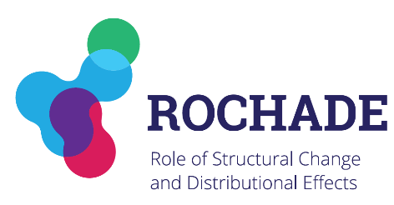
ROCHADE Stakeholder Dialogue

Time and place
Date: March 10th 2020
Time: 14.00pm – 18.00pm
Location: Mercator Research Institute on Global Commons and Climate Change (MCC)
EUREF Campus 19
Torgauer Straße 12-15
10829 Berlin
Room: Konferenzraum

Agenda March 10th Stakeholder Dialogue
Session and policy-relevant research topics (including discussion and feedback from stakeholders)
14:00 - 14:20 Introduction: project overview and goals (PIK)
14:20 - 14:50 Coal-phase-out (MCC)
14:50 - 15:20 Sectoral impacts and transformation (IfW, Uni Giessen)
15:20 - 15:40 India Case study (all)
15:40 - 16:10 Coffee break

Session on scenario
16:10 - 17:00 Scenario Explorer (PIK)
17:00 - 18:00 Interactive Scenario Design (all)
18:30 Dinner

Participants
Jörg Linke | (GIZ)
Franziska Bock | (GIZ)
Johanna Wehkamp | (BMU)
Juliette de Grandpre | (WWF)
Sebastian Scholz | (Nabu)
Jan Steckel | (MCC)
Matthias Kalkuhl | (MCC)
Lorenzo Montrone | (MCC)
Gabriel Felbermayr | (IfW Kiel)
Hendrik Mahlkow | (IfW Kiel)
Michael Hübler | (Uni Giessen)
Marcos Marcolino | (PIK)
Johannes Koch | (PIK)
Marian Leimbach | (PIK)

